Lesson 15

Testing User Interfaces (GUI) and Web Applications

1. **Test the UI/UX of the Mayo Clinic website:**

Bug 1

**Title/Summary**

The Mayo Clinic website loses functionality when excessively zoomed out.

**Description**

The interactive elements that rely on precise touch or click areas, such as small buttons or icons, are impossible to use when excessively zoomed out.

**Steps to reproduce**

1. Launch the <https://www.mayoclinic.org/> app.
2. Zoom out to 25%

**Expected Result**

The elements in the app should remain accessible when excessively zoomed out.

**Actual Result**

The elements in the app are inaccessible when accessible zoomed out.

**Environment**

Google Chrome Version 118.0.5993.88

**Attachments**

**Severity**

Medium

**Priority**

Low

Bug 2

**Title/Summary**

When creating an account at Mayo Clinic, the user cannot choose a date of birth above 2010.

**Description**

Before submitting the patient's information, the user has no choice for the date of birth above 2010.

**Steps to reproduce**

1. Launch <https://www.mayoclinic.org/>
2. Press the Login button in the upper right corner.
3. Click on the Create Account option.
4. Select the Birth Date
5. Fill out the form with the credentials of a user born in 2011.

**Expected Result**

The Birth Date section should accept dates above the year 2010.

**Actual Result**

The Birth Date section does not accept the dates above the year 2010.

**Environment**

Google Chrome Version 118.0.5993.88

**Attachments**

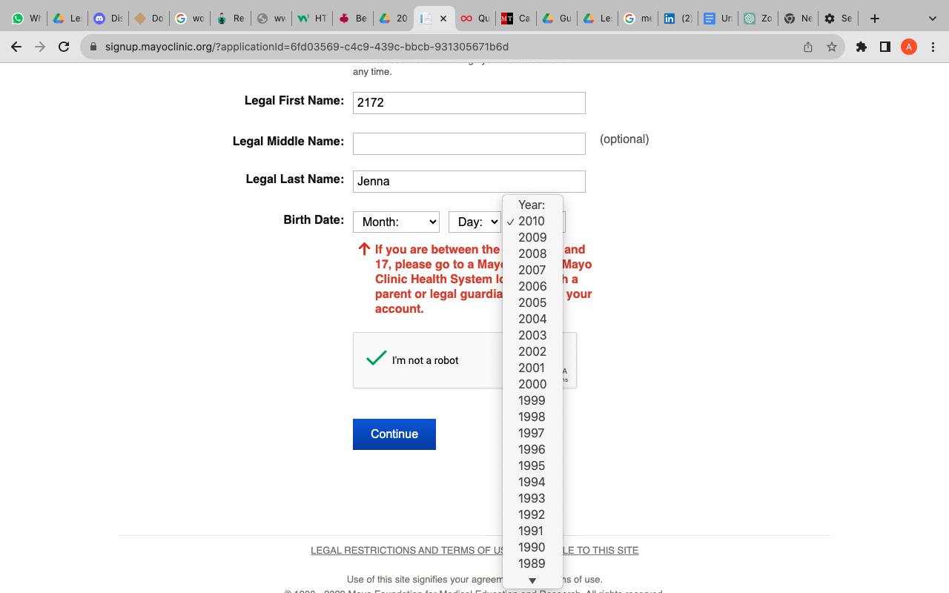

**Severity**

Critical

**Priority**

High

Bug 3

**Title/Summary**

The element is not clickable.

**Description**

The element is highlighted but not clickable when accessing the Patient Online Services.

**Steps to reproduce**

1. Launch the <https://www.mayoclinic.org/>
2. Click on the Login button.
3. Click on the highlighted element, Patient Online Services.

**Expected Result**

The user should be redirected to the Patient Online Services menu.

**Actual Result**

The user cannot click the highlighted element.

**Environment**

Google Chrome Version 118.0.5993.88

**Attachments**

**Severity**

Medium

**Priority**

High

Bug 4

**Title/Summary**

The Logo is not clickable in all situations.

**Description**

When accessing different elements on the app, the user cannot return to the homepage by clicking on the Logo.

**Steps to reproduce**

1. Launch the <https://www.mayoclinic.org/>
2. Click on the Login button.
3. Click on the Mayo Clinic Logo in the upper left corner.

**Expected Result**

The user should be redirected to the homepage.

**Actual Result**

The Mayo Clinic Logo is not clickable.

**Environment**

Google Chrome Version 118.0.5993.88

**Attachments**

**Severity**

Low

**Priority**

Low

Bug 5

**Title/Summary**

Subscription submitted with invalid credentials

**Description**

The user can sign up for free e-newsletters with invalid credentials.

**Steps to reproduce**

1. Launch <https://www.mayoclinic.org/>
2. Go to the Sign up for free e-newsletters on the footer menu,
3. Fill out the email: [a@b.com](mailto:a@b.com)
4. Fill out the name: 1234
5. Click on Submit.

**Expected Result**

The user should not be able to submit the form with invalid credentials.

**Actual Result**

The user can submit the form.

**Environment**

Google Chrome Version 118.0.5993.88

**Attachments**

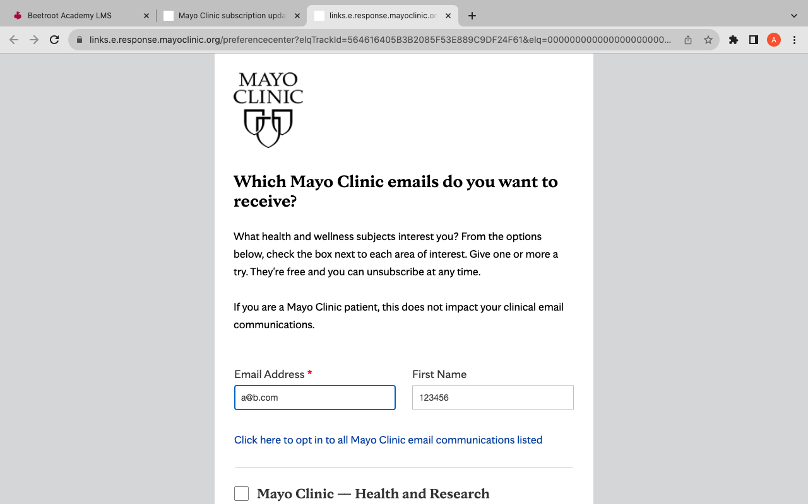

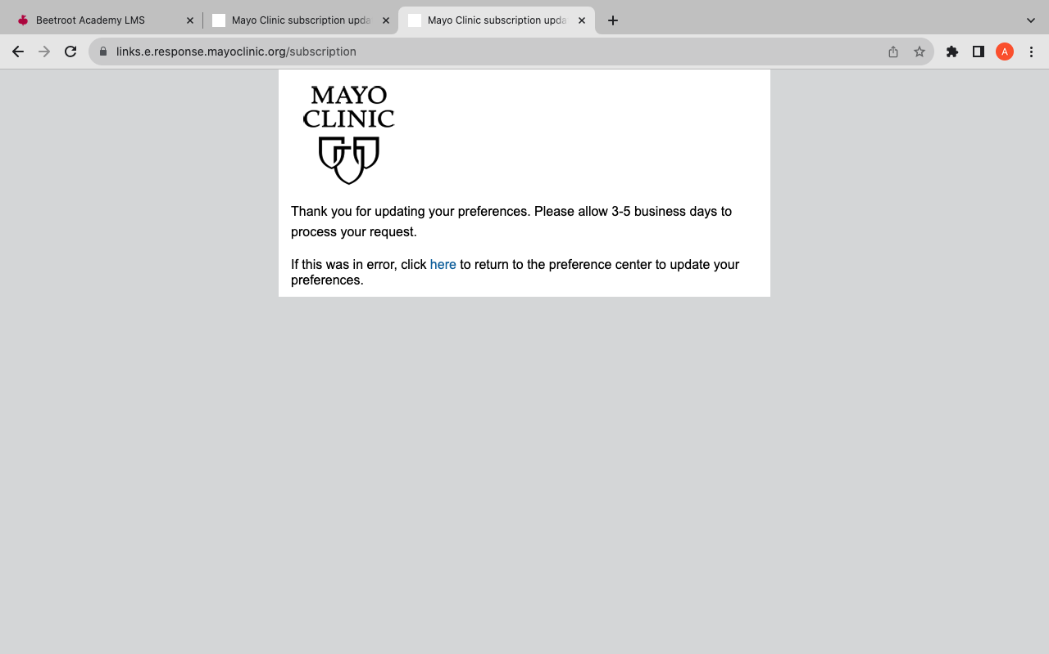

**Severity**

High

**Priority**

High

Level 2

**Conduct cross-browser testing of the bugs you found earlier in three different browsers.**

* For what appears to be a bug 1 in Google Chrome Version 118.0.5993.88, the <https://www.mayoclinic.org> website on Safari Version 15.6.1 (15613.3.9.1.16, 15613) cannot be excessively zoomed out; it is not losing its functionality. On the other hand, on the Microsoft Edge Version 118.0.2088.61 (Official Build) (x86_64), the website behaves the same in Google Chrome Version 118.0.5993.88.
* Bug 2 has the same behavior on all three browsers.
* Bug 3 has the same behavior on all three browsers.
* Bug 4 has the same behavior on all three browsers.
* Bug 5 shows the same behavior on the Microsoft Edge Version 118.0.2088.61 (Official Build) (x86_64) and Google Chrome Version 118.0.5993.88. For the Testing in Safari Version 15.6.1 (15613.3.9.1.16, 15613), the user can submit his request if he clicks on one opt-in Mayo Clinic email communications listed.

Level 3

**Use Developer Tools to record the font used, its size, color, and background color of the following elements at Mayo Clinic:**

* ‘Log in to Patient Account’ in the header
* ‘Learn more about Mayo Clinic’ button
* feedback rate buttons (numbers from 1 to 5, presented within the feedback form, which can be called by clicking on the Feedback button (bottom-right corner))
* Language labels for language change

1. Log in to the patient account in the header

font-family: 'mayo-display', serif;

font-size: 44px;

background-color: rgb(255, 255, 255);

color: #000000;

1. Learn more about Mayo Clinic button

font-family: var(--mc-typography-font-family-sans);

font-size:calc(var(--mc-typography-font-size-5x)/var(--mc-typography-font-size-root)*1*1rem);

color: var(--mc-color-text-primary);

background-color: var(--mc-color-background-primary);

1. Feedback rate buttons (numbers from 1 to 5, presented within the feedback form, which can be called by clicking on the Feedback button (bottom-right corner).

font-family: Roboto,"Helvetica Neue",sans-serif;

font-size: 100%;

background-color: initial;

color: fieldtext;

1. Language labels for language change

font-family: var(--mc-typography-font-family-sans);

font-size:calc(var(--mc-typography-font-size-4x)/var(--mc-typography-font-size-root)*1*1rem);

color: var(--mc-color-text-primary);

background-color: var(--mc-color-background-primary);